5/2012
SJCOG Board

Staff Report

SUBJECT: Annual Programmatic Adjustment of the Regional Transportation Impact Fee (RTIF)

RECOMMENDATION: Information

DISCUSSION:

The RTIF Operating Agreement was fully executed by SJCOG and all member agencies by April 2006. As part of the program’s policy, the RTIF structure will be adjusted on an annual basis. Section 3.2 from the Operating Agreement states that the fee shall be adjusted by each Participating Agency on an annual basis at the beginning of each fiscal year (July 1) based on the Engineering News Record California Construction Code Index (CCCI).

The year 2010 annual adjustment in the fee structure resulted in a -0.49% decrease based on CCCI data from April 2009 to April 2010. For year 2011, the difference between the April 2010 (5270) and 2011 (5636) CCCI supports an increase of 6.95%. In May of 2011, the SJCOG Board of Directors approved a temporary suspension of the annual fee adjustment. Due to the increase supported by the methodology, in May of 2011, the SJCOG Board of Directors approved delaying the implementation of the RTIF adjustment pending completion of the AB 1600 RTIF update in the fall of 2011.
An analysis was conducted on different indexes that could be used to annually adjust the program’s fee structure. As part of the adoption of the 5th year update of the RTIF program, the SJCOG Board of Directors approved to: 1) ccontinue using the CCCI on an annual rolling average; and, 2) reinstitute the fee adjustment process to begin on July 1, 2012.

Attached is the most recent update of the CCCI from the State Department of General Services. Historically, the annual difference for the month of April is used for the analysis in order to allow participating agencies the time to incorporate the difference in the fee schedule into their systems in order to be ready for implementation by July 1st of every year.

The fee adjustment calculates the annual rolling average beginning from April 2011 (CCCI of 5636) and April of 2012 (CCCI of 5740). The average of the two (2) years establishes a modified CCCI for March 2012 of 5688. Compared to the CCCI for 2011, this would support a fee increase of .914%. The following table on the next page reflects the increase in the fee structure based on this methodology:

Prepared by: Michael A. Swearingen, Senior Regional Planner
RTIF.FeeAdj.Board.5.12_2.docx
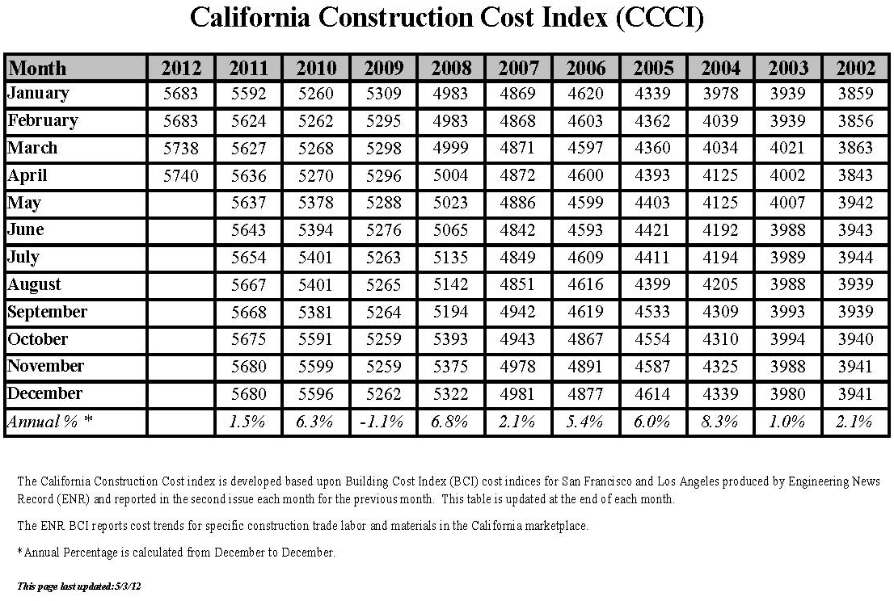
April 2012 X = 5688

