May 23, 2017

10:00 a.m.
Weekly meeting of all departments with involvement in development projects to discuss issues, review status, and coordinate responses required for the success of the project.
Invitees: CDD Director, Greg Showerman
PW Director, Mark Houghton
Parks & Rec. Director Kevin Fant
City Engineer, Kevin Jorgensen
Chief Building Official, Brad Wungluck
Planning Manager, Mark Meissner
Fire Marshal, Lantz Rey
Senior Planners, Rochelle Henson, J.D. Hightower
Associate Planner, Mandy Kang
Assistant Planner, Elizabeth Yee
- Open issues
- Luxury Apartments – Traffic Signal.
- Woodbridge Apartments – URSP MMRP
- Confirm the expiration date which appears to be December 9, 2017, based on COA #3 on the 3rd page of the attached resolution.

- Confirm the milestone that needs to be reached to meet the requirement of the land use entitlement specified in Section 17.08.120.B. which states that, “The exercise of a land use entitlement occurs when the property owner has performed substantial work and incurred substantial liabilities in good faith reliance upon such permit to the satisfaction of the Community Development Director.”

- Request an updated fee estimate or confirmation that the attached fee estimate is still valid.

- Accessory Dwelling Units – Draft Ordinance.
- DCT Development Agreement
- On Call Contract – Fehr and Peers.
- Temporary Use Permit Fee – Standard and Economic Development.
New business

- Ludwig Property – Woodward Right-of-Way dedication
- Professional Services Agreements – Length of Process.
- Coordination Improvements w/PW Engineering
- Silva Estates II Landscape Improvement Plans
- Gordon Research Property / Nur Al-Huda Academy:The Academy has also asked Genesis Engineering to provide assistance in working with the City and other entities on the redevelopment of the site. So, I’m emailing today to get started on the redevelopment part of things. I realize that you will not be dealing with most of this personally, but I would appreciate it if you would direct me to the appropriate people in the City government to talk to. Specifically, I’d like to talk to the person(s) in charge of:
- Requirements for the wall around the new development;
- Upgrading of the storm/SSJID irrigation pipe beneath the property; and
- CEQA requirements for redevelopment.
- Post-Construction Devices in City ROW/Maintained Areas
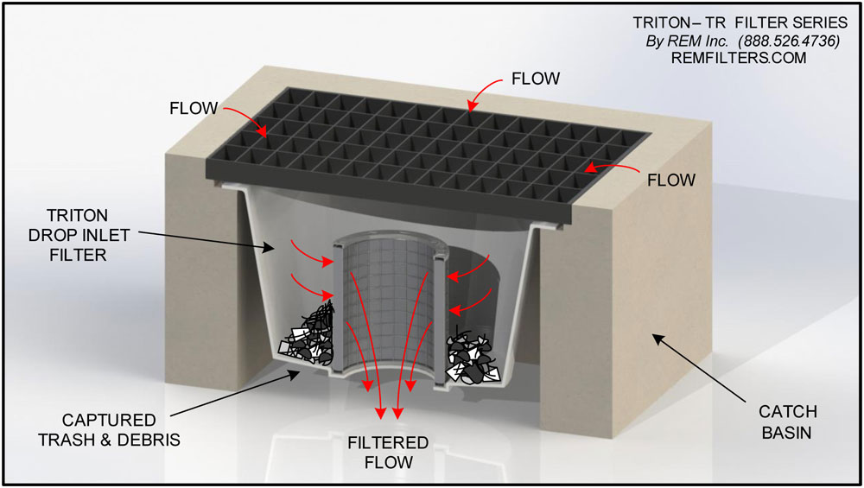REM Triton Drop Inlet Filter – The REM TRITON Filter is an effective and economical solution to help property owners, corporations and municipalities meet storm water quality requirements and regulations. Easily installed immediately below the grate in storm drains and in catch basin inlet structures the REM TRITON filter utilizes a patented media cartridge system that effectively removes pollutants from stormwater. Appropriate for industrial, commercial, retail and municipal applications, the filter is available for most common size catch basins. Media strategy may be custom configured for specific pollutant concerns.
Used in downtown Riverbank and new subdivisions, REM provides service. May be more cost effective maintaining bio-retention swales and create less locational conflicts for conventional subdivisions. Maintenance costs could be put into CFD.
All of REM products are made to be consistent with Jensen boxes and are rated for 100% trash removal product. The cost per unit is $345 for 24” round; $550 for 2’X3’; and $245 for 12”X12” plus install. Service runs approximately $50 per unit; 3 times a year or $150 per unit annually. REM provides all reporting and disposal. For more information please call Marcel at (925)676-4736 or his cell at (925)858-8005.
- Adjournment

