THIS ONLY APPLIES WITH EXISTING EMAIL ACCESS

- Download Outlook for iOS from the iOS App Store and then open it. The icon looks like this:
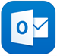

- If it's your first-time using Outlook for iOS, enter your full email address, then tap Add Account.
If not, open the Menu > tap Settings > Add Account > Add Email Account.
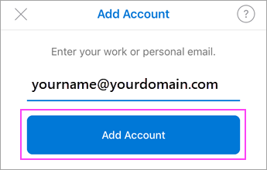

- Enter your email account password and tap Sign In.
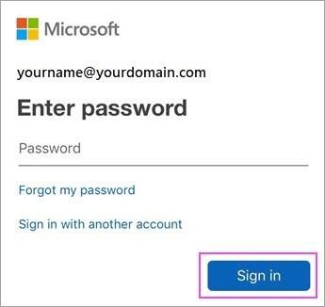

- If multi-factor authentication is enabled, verify your identity. If it’s not enabled, it will take you to step 5.
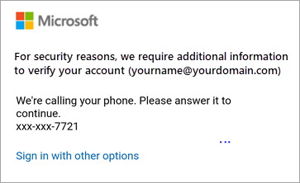

- US Government Account Detected Prompt – Select OK

- Enable Notifications Prompt – You have the option to turn on or off.

- At this point your email will have synced.
Please contact IT if you have technical difficulties. http://helpdesk or Ext 8800

