THIS ONLY APPLIES WITH EXISTING EMAIL ACCESS

- Download and Install the Outlook for Android app from the Google Play Store and then open it.
Tap Get Started if this is your first time.
Otherwise, to add another email account, open the Menu > Settings > Add Account > Add Email Account.

- Enter your full email address, then tap Continue.
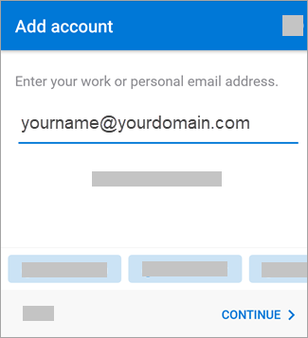

- Enter your email account password and tap Sign In.
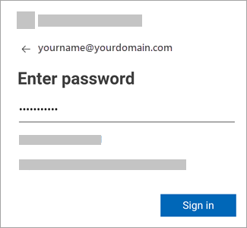

- If multi-factor authentication is enabled, verify your identity. If it’s not enabled, it will take you to step 5.
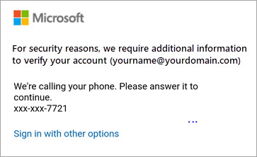

- Government Community Cloud Prompt (GCC) – Select OK

- At this point your email will have synced.
Please contact IT if you have technical difficulties.
http://helpdesk or Ext 8800

