Each column is filtered to make searching easier. The filter identifies all unique values in a column; you can use filters to choose what you want to see displayed. This guide illustrates some ways of using these filters.
1. At the top of each filtered column, there is a small square with a downward-facing arrow:
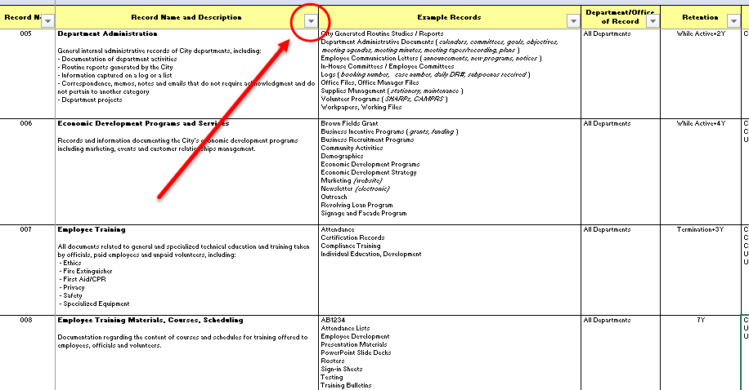
This is the MS Excel filtering tool.
2. To see the filter contents for a particular column, click on the downward-facing arrow. This will display the filter window:
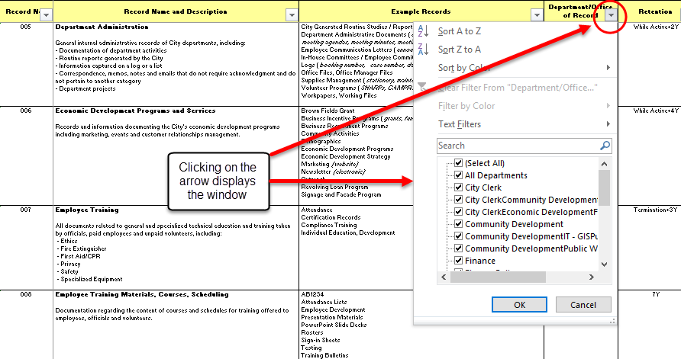
The filter display window appears directly below the column selected. (Note: This may vary from one computer to another.)
3. The default is that all the available terms are selected. You can tell that this is true because the (Select All) box has a check mark (and all the selections also show check marks). A scroll bar along the right side will allow you to move down or up to see selections that don’t fit in the window’s display.
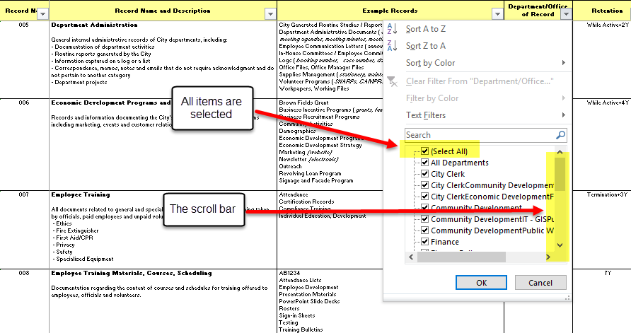
4. To see rows in the spreadsheet for only a single filtered selection, click on the (Select All) box (to turn that option off), choose the selection in the list that you want to see, then click OK. For this example, which uses the Department/Office of Record column, I’ve selected City Clerk:
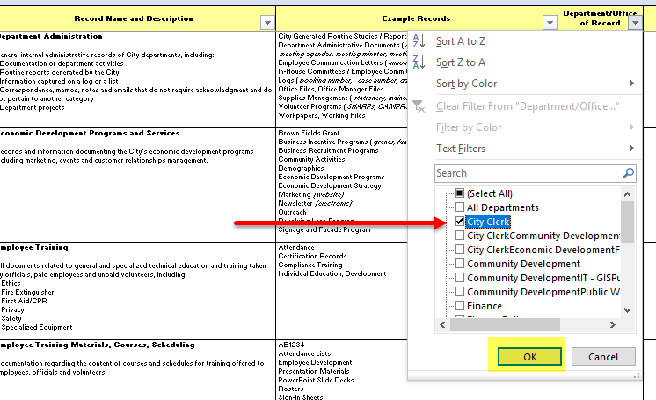

5. Now the only rows visible in the spreadsheet are for City Clerk:
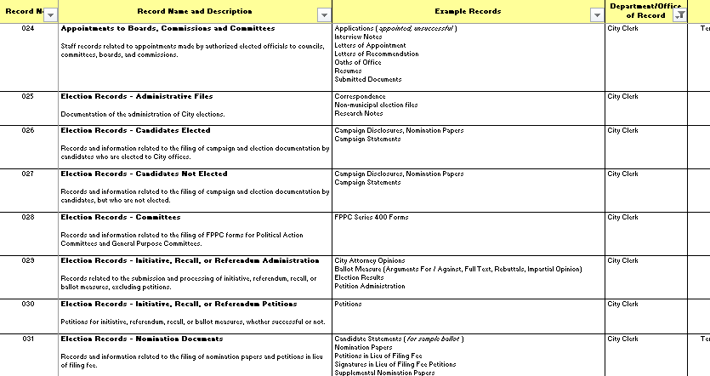
Note that the filter tool icon has changed from an arrow to a little filter image:
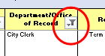
You can always tell if there’s a filter in effect if the filter icon looks like a filter, rather than an arrow.
6. To change the filter, click on the filter tool icon again and either change the selection(s) you want to view, or remove all filters by clicking on Clear Filter From “Department/Office of Record” or by clicking on the box next to (Select All), then click OK:
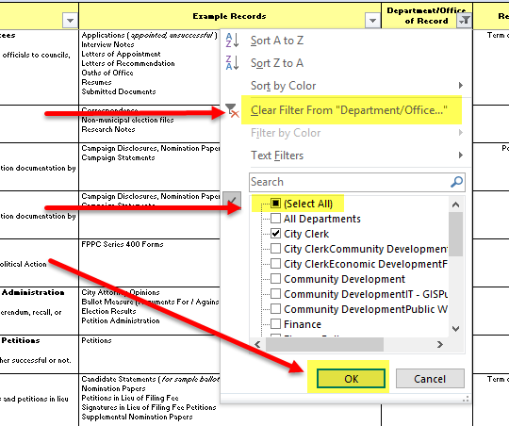

7. The filtering tool has many more options that can be helpful. One of these is the Search feature:
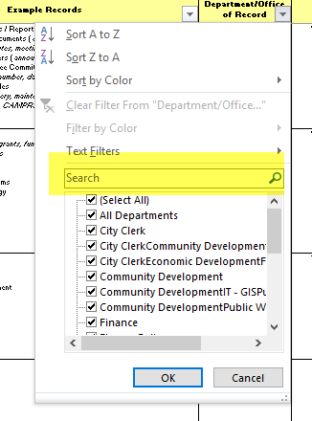
8. To see only those Example Records that contain the term report, launch the filter window for the Example Records column, type in the search term, and click OK:
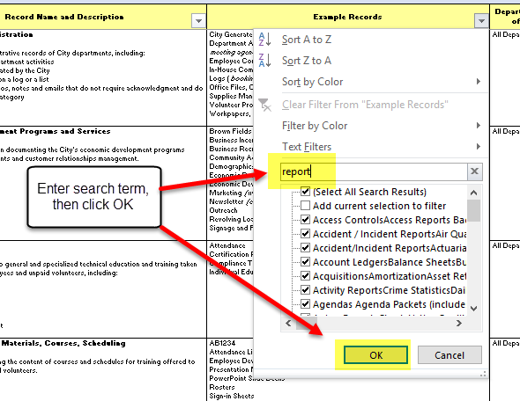
9. The results will display only those rows where the term report appears somewhere in the Example Records. To clear this filter, follow steps described in Step 6, above.
This is only an introduction to the use of filters in Excel. There are many other features in the filter window; try exploring to see what you can do. If you find something useful, share with others!

