Contents
Security Flow Chart 2
Roles 3
Create a Role 3
Add Roles to Employees 5
Workflow Configuration 6
Create Steps 6
Create Workflow 8

Security Flow Chart

Configuring security and workflow is a multi-step process.
- Roles must be created.
- Once created, those roles must be attached to the appropriate employees.
- After roles have been assigned to employees, the workflow must be created to assign the appropriate employees to the appropriate supervisors for approval access.

Create Roles Add Roles to Employees Create Workflow

Roles
System Admin| Security and Permissions
The first step in setting up security is creating Roles. Roles determine what access the user will have in the system and which employees supervisors will be able view.
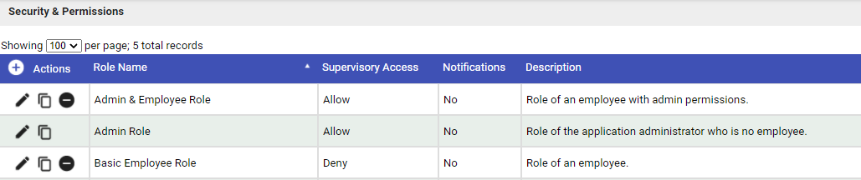

Create a Role
- Click on the plus sign to add a new record.
- To copy and existing role, clock on the copy icon .

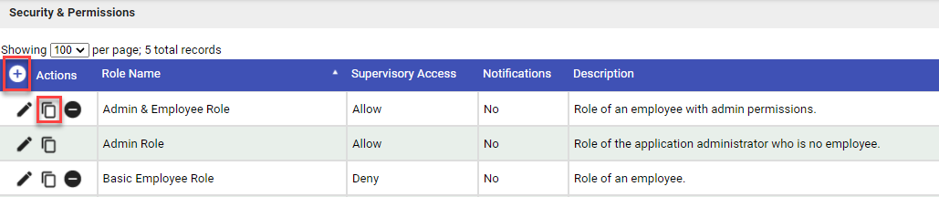

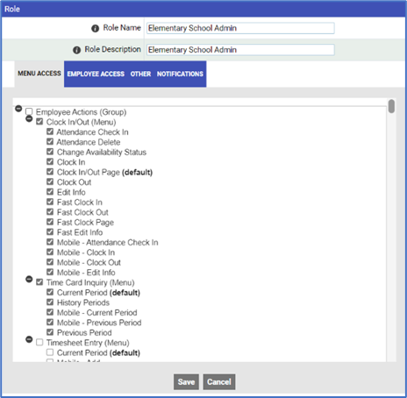
- Fill in the following information or update if copying roles.
- Role Name - – Enter the name for this role
- Role Description – Enter the description for this role
- Menu Access tab - Check the menu items that this role should be able to access.
  - Employee Actions
  - Supervisor Actions
  - Reporting
  - Payroll Functions
  - System Admin
  - System Configuration
- Employee Access tab - choose the employees or department that this role should be able to access.
- Other tab - chose the appropriate checkboxes for the role.
  - Allow Supervisory/ Workflow Access (This must be checked for supervisors)
  - Access to Overtime/Comptime Hours Selection Box
  - Allow Availability Status Change
  - Allow access to job costing split on Time card
  - Information icon Allow selection of overlap action for split-type pay codes
  - Allow access to Exclude Auto Deduction
  - Initial Screen
  - Default Clock In/Out Pay Code
  - Disable All Clock In/Out Actions
  - Allow Bulk Approval from Employee Time Summary

- Notifications – This can be ignored. This is now maintained in workflow management.

Add Roles to Employees
System Admin/ Master File Management/Employees
- Click on the pencil to edit the employee record.
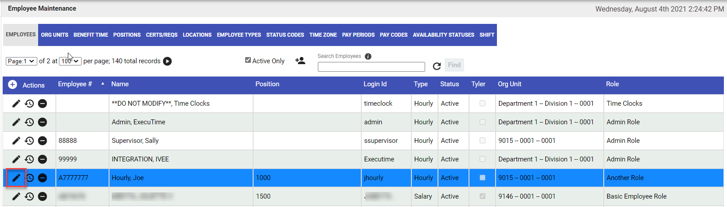

- Under the Security tab, enter the role under the Permission Role and save.
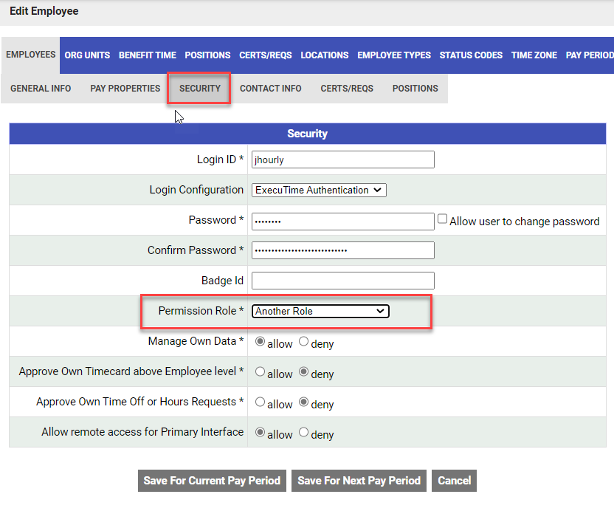

Workflow Configuration
- The Workflow Configuration determines who will be responsible for approving time, time-off requests and/or hours requests.
- Workflow for Time Approval, Time-Off Requests and Hours Requests are configured separately.
Workflow Creation Process
- Create Steps.
- Assign Primary and Secondary Approvals.
- Assign Criteria.

Create Steps

Different organizations have different approval processes. Some organizations have a one-step approval process, while other organizations may have a multi-step approval process. Steps determine how many people must approve time cards, time off-requests and/or hours requests to be considered fully approved.

System Admin/ Workflow Management/Workflow Approvals/ Time Approval
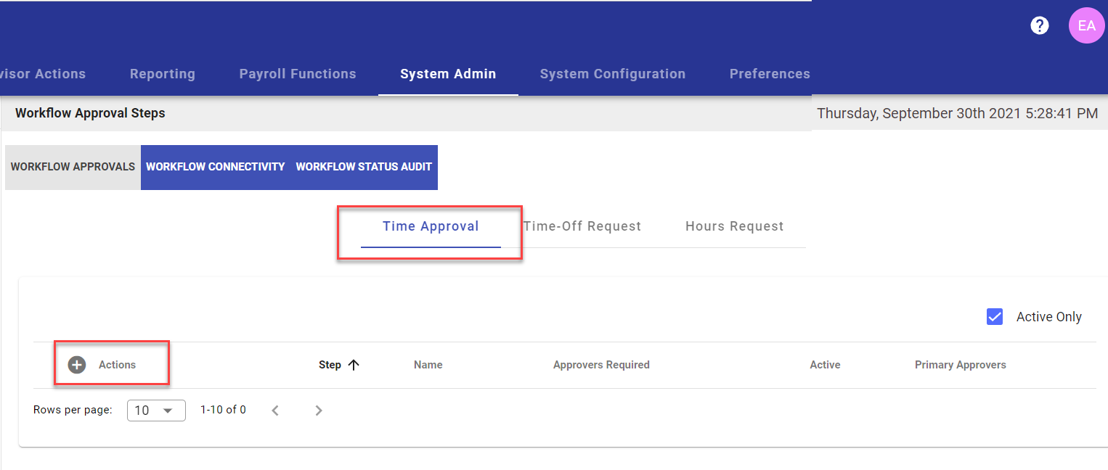
- Choose the appropriate Workflow. Click on the Add New Entry icon

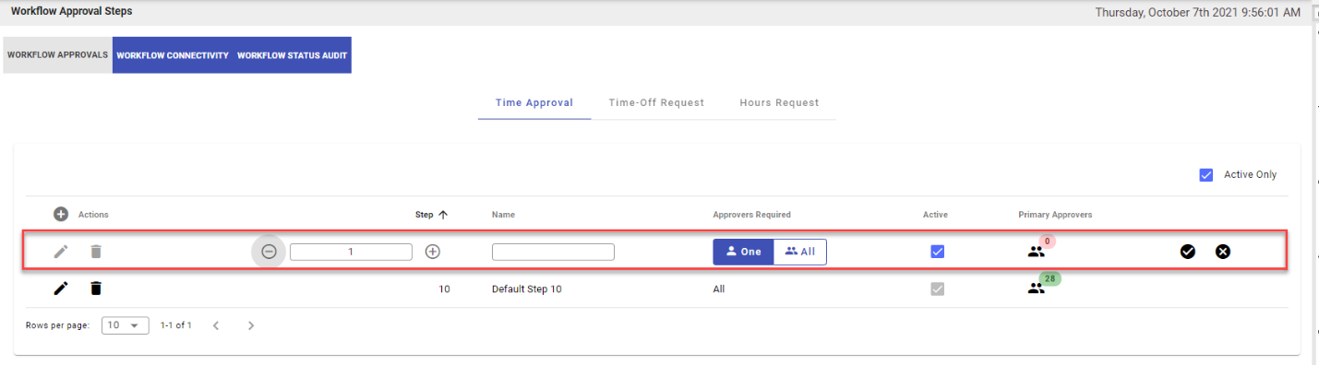
- On the newly added Step Configuration row chose the following:
- Step
  - Choose the step number. If multiple approval steps are needed, the step number determines the order in which the time cards must be approved.
  - Use the plus and minus icons to change numbers.
- Name
  - Enter the name of the step. For example, Supervisor Approval or Level 1 Approval
  - This can be changed at any point.
- Approvers Required
  - One - – If an employee falls in several workflow setups within the same step, only one approver must approve the timecard before the timecard moves on to the next step.
  - All – If an employee falls in several workflow setups within the same step, all approvers must approve the timecard before the timecard moves on to the next step.
Example:
In the first step, the Bus Supervisor approves all time entries for the bus driver position. The Food Service Supervisor approves all time entries for the cafeteria position.
Joe Hourly works as both a bus driver and cafeteria worker. His time card will have entries for his bus driver position and cafeteria position.
- If Approvers Requires is set to One, either the Bus Supervisor or Food Service Supervisor can approve the time card for that step to be considered complete.
- If Approvers Required is set to All, both the Bus Supervisor and Food Service Supervisor must approve the time card before that step is considered complete.

- Click on the checkmark to save the step.

Create Workflow

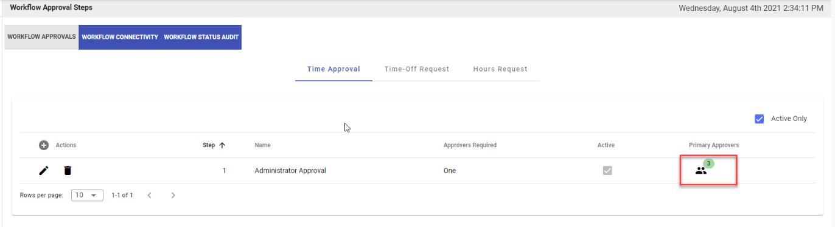
- Next to the Step name, click on the Primary Approvers icon to add or edit a workflow to that step.
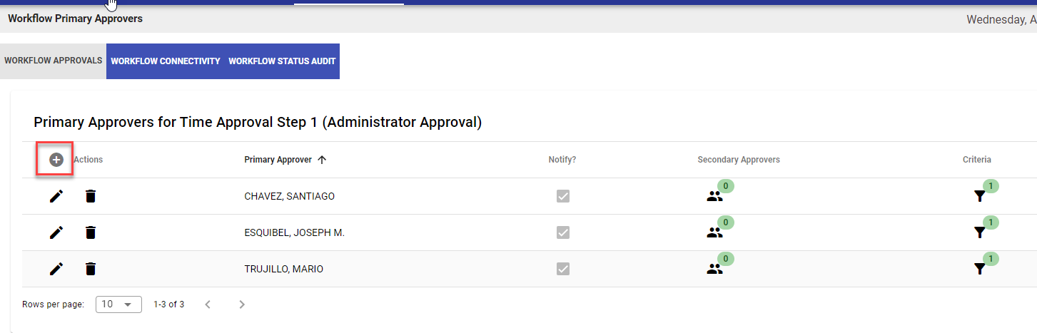
- Any existing workflows will appear. Click on the Add icon to add a new workflow or the edit pencil to edit an existing one.
- Choose the Primary Approver.
- If a supervisor does not display, check that the user has the correct role with supervisory access.

- Click on the checkmark to save the record.
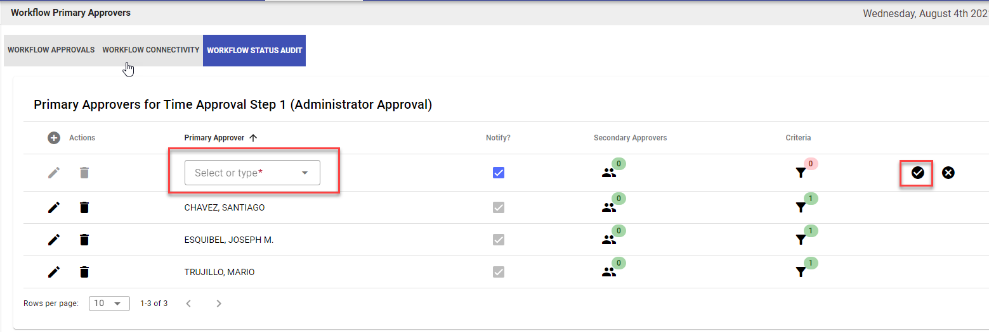

- Once saved, click on the Criteria filter funnel to assign employees to that primary approver.
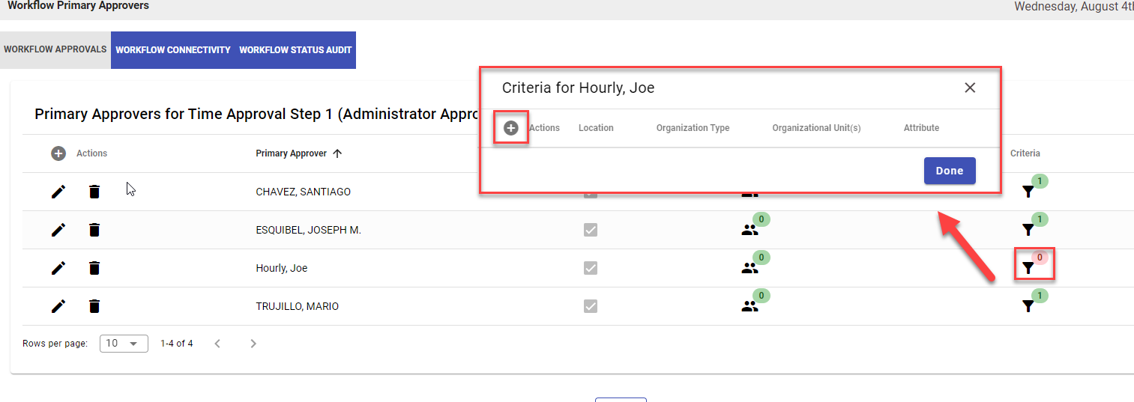
Click on the Add icon to add the criteria.
6) Choose the criteria to assign approval rights.
- Locations – Choose the appropriate location to assign by location.
- Organization Type
  - Choosing Department under Organization Type will allow the approver to approve at a department wide level.
  - Choosing Employee under Organization Type will allow the approver to approve by individual employees.
- Attribute(not required) – Approval may also be assigned by the following:
  - Job Costing Code
  - Pay Code
  - Position Code
  - TA Shift or AS Schedule.
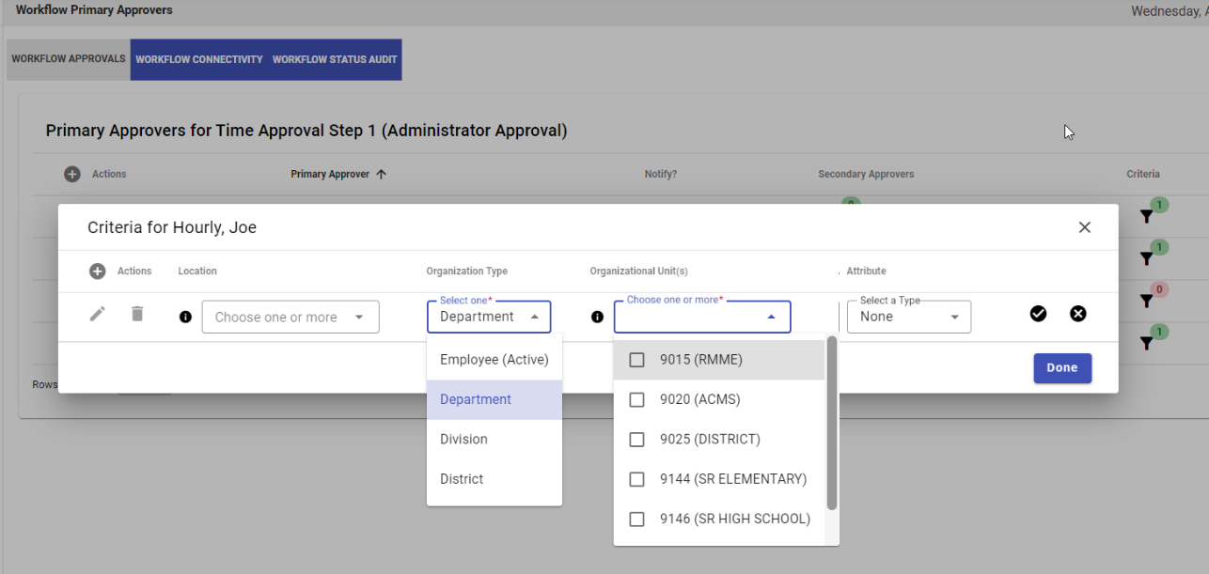

7) Repeat this for Time Off Requests and Hours Requests.
