CityMPF Weekly Update
Author(s) | Malinda Loera, Melissah Pérez, Tabitha Fraser, Trevor Wyatt
Original Date of Publication | July 13, 2016 | Modified Date | May 15, 2017

Overview

This document outlines the weekly process for updating the City Master Parcel File (CityMPF).

The San Joaquin County GIS Division will send an email to City GIS staff when the weekly update is ready for download from the County’s FTP Site. Please see the last page of this document for a list of contacts.

First Time FileZilla Set-Up

If this is your first time working with the CityMPF, you will need to set up the connection in FileZilla.

1. Open FileZilla. If FileZilla is not installed, download the FileZilla Client from https://filezilla-project.org/. You will need admin access to your computer.

2. Set-Up Connection

a. Open FileZilla and go to File->Import…
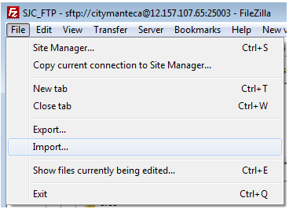

b. Navigate to \\utopia\it\database\Assessor\FTP\ and choose ‘FileZilla.xml’. When the Import Settings window opens, leave everything checked and click okay.
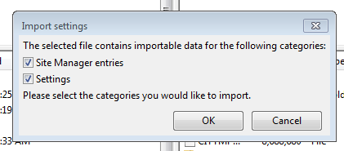

b. Open the Site Manager by clicking the icon underneath File in the upper left corner.
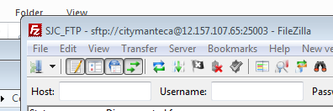

d. Go to Edit->Settings…
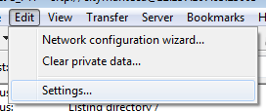

e. Select SFTP from the Select page: directory, then click Add key file…
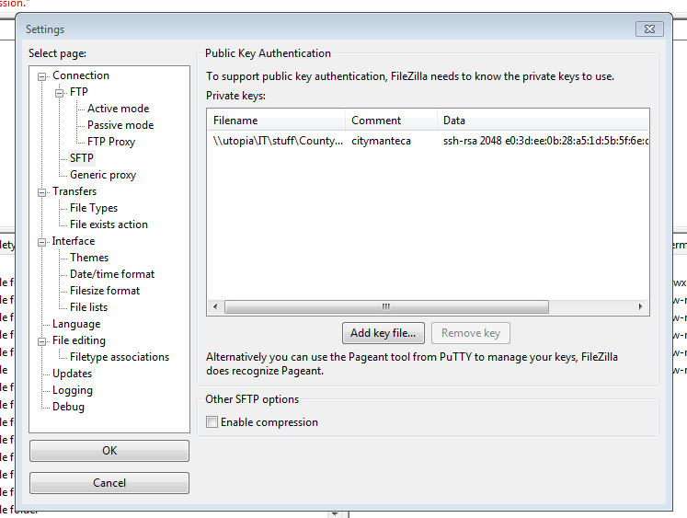

f. Navigate to \\utopia\it\database\Assessor\FTP\FTP Key and select ‘citymantecab.ppk’. If you need to unzip the folder, the password is ‘Pennie123’. Click OK.

g. Open the Site Manager again and click Connect. If everything worked correctly, you will see a folder named ‘/’ appear on the Remote Site side of the main window, with the folder ‘Manteca_Data’ inside of it.
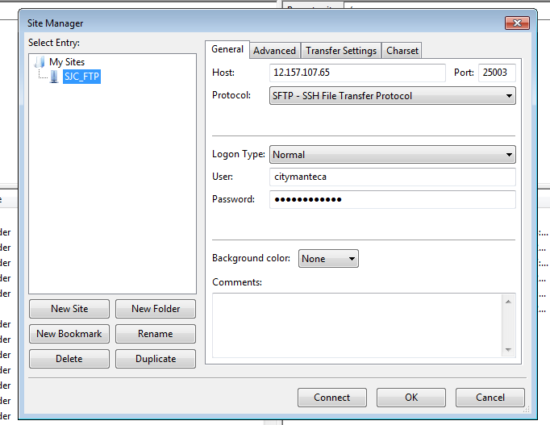

Download the CityMPF

- Rename Old File

- Open FileZilla and connect to the SJC FTP site. (Open site manager and click Connect. You will need to do this every time you open FileZilla.)

- Rename last week’s CityMPF file to include the date it was created by the County.
Do not use the date the file was downloaded.

(i.e. CITYMPF to CITYMPF_070516)
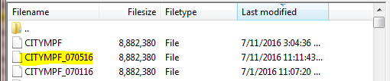

File location: \\utopia\it\database\Assessor

- Download the New File

a. Double-click the new file from the County’s FTP Site to download the file to \\utopia\it\database\Assessor

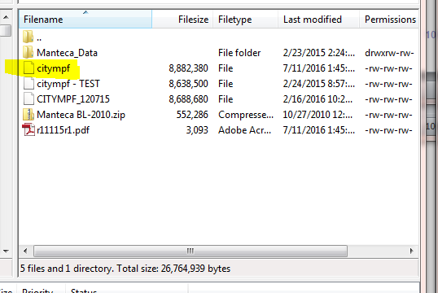
- Rename New File

a. Rename citympf to CITYMPF (all caps, no date).

- Verify File

a. Check File Size

Verify the size of the file is equal to or greater than the previous week’s file. If it’s smaller, SJC will need to re-export the file.

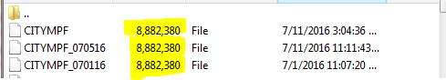

b. Check for Proper Formatting

Open the file in Notepad and turn off Word Wrap (View->Word Wrap). Your screen should look like the graphic below:

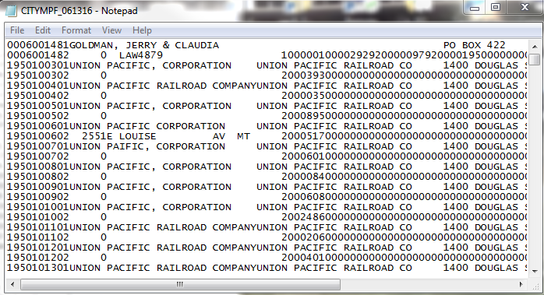

If the data appears like the graphic below, ask the County to re-export the file - Line breaks are required.

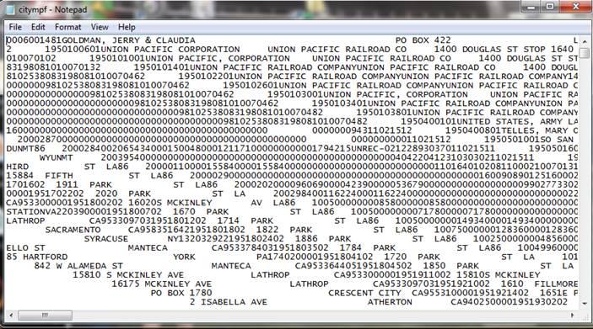

Update the Logos Database

1. Import CityMPF File to the Intranet

a. On the City’s Intranet site, go to Departments->Information Technology -> GIS ->CityMPF Update.
http://intranet/Technology/_Layouts/KaliyanData/default.aspx

b. Click on Import CityMPF File/Export Logos Files.

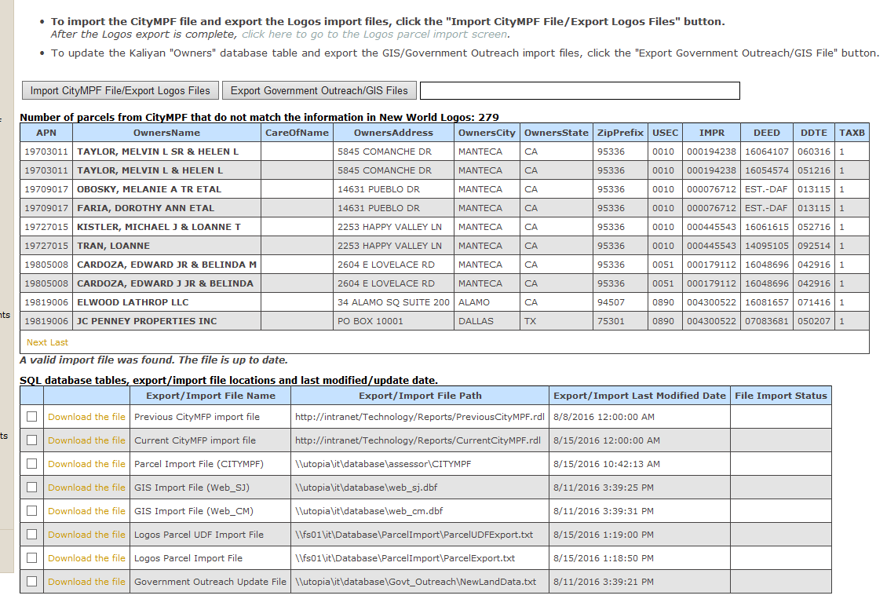

This will import a new CityMPF file, if available, and export the Parcel and UDF (User Defined Fields) text files for import to the Logos database.

NOTE: The Logos database must be updated before exporting the GIS update files (Section: Update Government Outreach).

The first list contains the differences between the current CityMPF file and the New World Logos database.

The second list contains the ‘Export/Import Last Modified Date’. If the transfer was successful you will see today’s date for ‘Current CityMPF import file’.

2. Import Parcels to New World Logos

a. Open New World in Internet Explorer.
Go to Community Development->Parcel Management->Parcel Import.

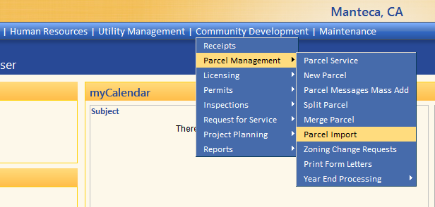

b. Click on the System Settings button and check the box for Owner Name. Make sure only the Owner Name box is checked. Click Save.

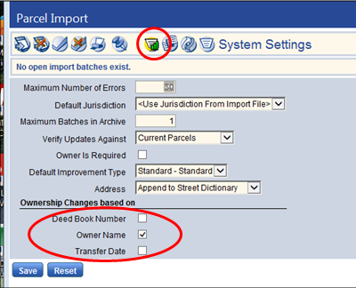

c. Click the Parcel Import button (red circle below), then click the Browse… button after Parcel and browse to \\fs01\it\Database\ParcelImport. Choose ‘ParcelExport.txt’.

Always have ‘Partial Import’ Checked!

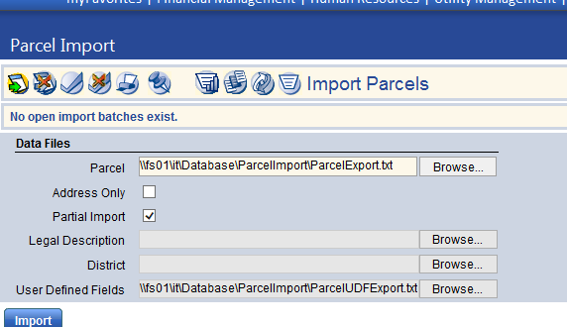

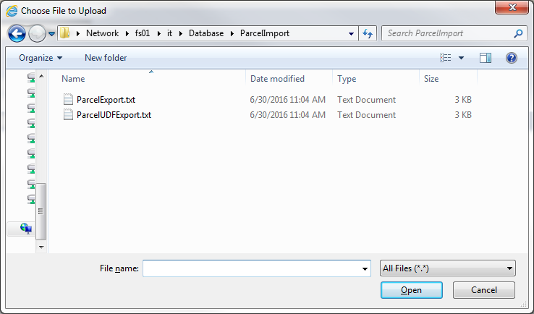

d. For User Defined Fields, browse to the same location (\\fs01\it\Database\ParcelImport) and choose ‘ParcelUDFExport.txt’.

e. Click Import.

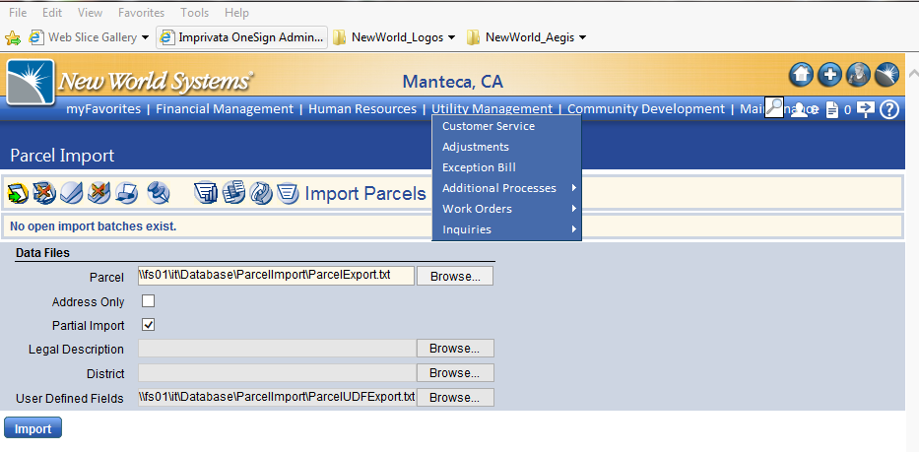

You see the results of the import. If the results do not appear after about a minute, click F5 to refresh.

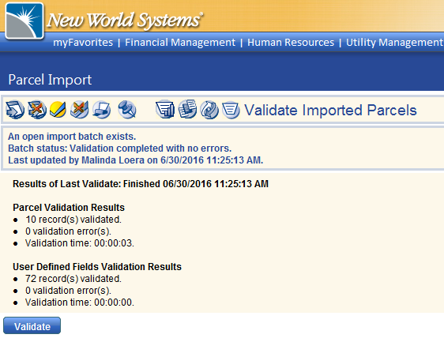
If there are errors (i.e. bad values in a field, formatting issues, etc.), you can view these under the Import Errors tab. You will not be allowed to continue the process until corrections are made. The raw file can be modified if not too many errors exist.

f. Click the Validate Imported Parcels button.

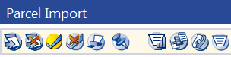

g. Click Validate.

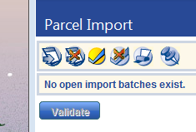

Use F5 to refresh until the Report appears. If errors exist at this point in the process, they will be noted here. Error types are address-related issues based on set parameters (i.e. duplicate addresses, the address is already assigned to another active parcel, etc). You may choose to continue here.
The records affected by the errors will not be updated, but the rest will.

h. Click Finalize Imported Parcels.

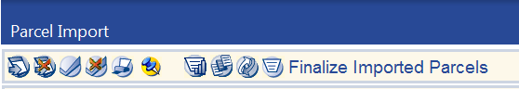

i. Click Finalize.

Use F5 to refresh until the Final Report appears.

j. Return to the Intranet and hit refresh. The number of parcels that differ between the CITYMPF and Logos should have decreased. If there are still differences remaining, return to New World and click System Settings, then check the box for Deed Book Number and click Save. Repeat Steps C-I. Repeat again for Transfer Date if necessary. Make sure to only check one box at a time.

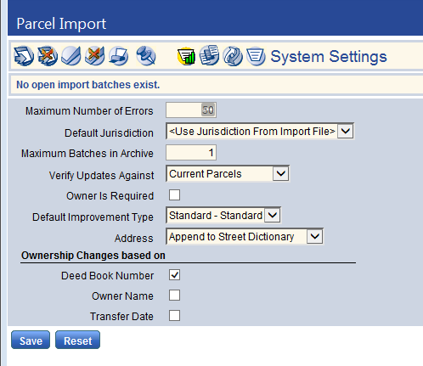

Export the Government Outreach Import File

- Make sure to take the previous week ‘NewLandData.txt’ add the date and save it.
EXAMPLE; ‘NewLandData_051517.txt’

2. Go back to Intranet page and click on Export Government Outreach/GIS Files.

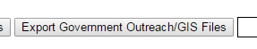

OPTIONAL - To view the output from “Export Government Outreach/GIS Files”, follow this link to access the ‘NewLandData.txt’ file: \\utopia\it\database\Govt_Outreach\NewLandData.txt

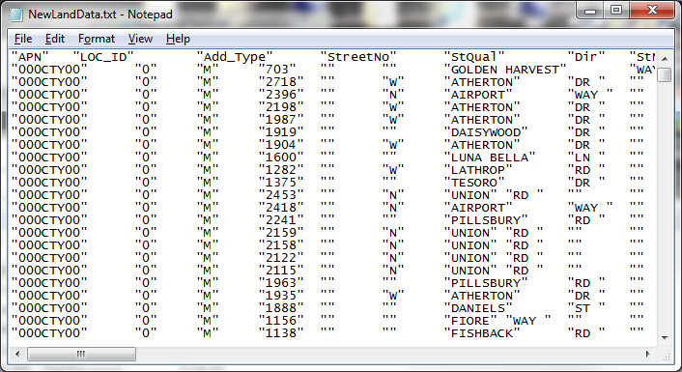

OPTIONAL- To access the ‘Web_CM.dbf’ and ‘Web_SJ.dbf’ import files used by the GIS scripts, follow this link: \\utopia\it\database.

Update Government Outreach

1. Import Parcels

a. In Government Outreach, go to Administration->Import Parcels.

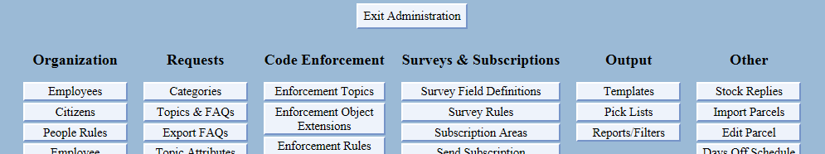

- Click Browse. Go to \\utopia\it\database\Govt_Outreach\ and choose ‘NewLandData.txt’. Make sure to select the file with today’s time stamp.

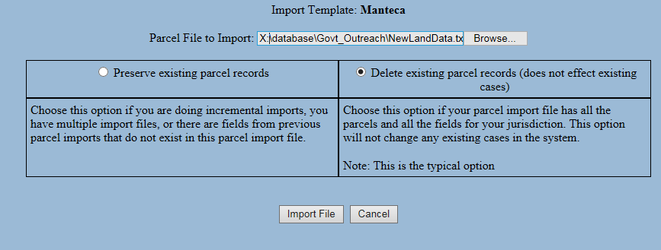

d. IMPORTANT – Make sure the Delete existing parcel records radio button is checked.

e. Click Import File. Click Commit Import at the bottom of the results page when the Import finishes.

Run GIS Scripts

1. Run Update_Dev _2016

a. Open ArcCatalog.

b. In the Catalog window, browse to \\Fs01\gis\Monthly_Editing\MPF Updates\WeeklyDataUpdate.tbx

c. Double-click model ‘1. Update_DEV_2016’. Click OK. Do not use the other Update_Dev.
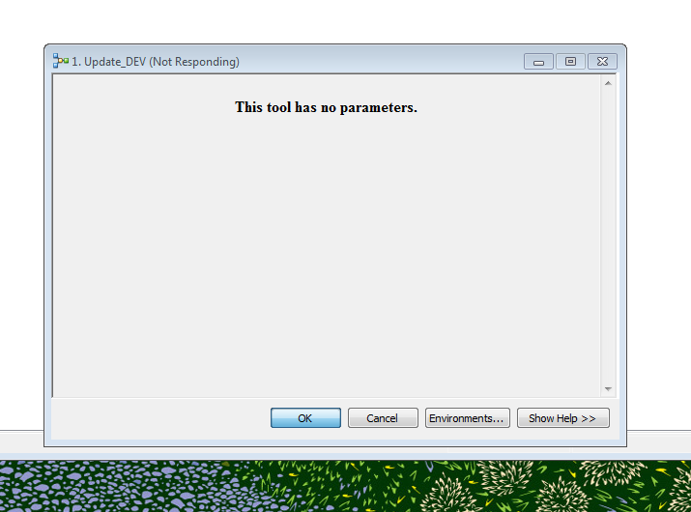
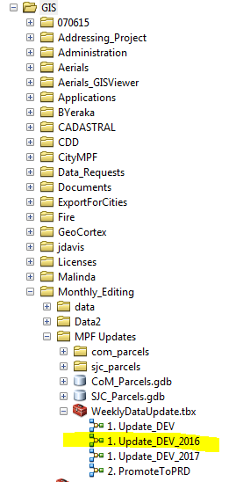

- Verify that

2. Verify GEODATA_ADMIN was updated.

a. Add GEODATA_ADMIN.SDE->GEODATA.DBO.DATA-> .GEODATA.DBO.Parcels_OwnerData to an MXD. Use Identify to spot check the parcels for data. Some parcels outside of the city limit may be missing data.

3. Run PromoteToPRD

a. Double-click model ‘2. PromoteToPRD’. Click OK. This will delete and append the data to SDE.

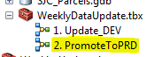

4. Verify SDE Updated

a. Open the GIS Viewer in Internet Explorer and ensure that the parcels are visible when you zoom in. If the parcels are missing, double check that GEODATA.DBO.Parcel_OwnerData was not empty and try re-running PromotetoPRD.

San Joaquin County Contacts

Daylin Johnson
djohnson@sjgov.org
For assistance with FileZilla and the FTP connection

Cathy Lesher
Information Systems Technician
San Joaquin County
Office of the Assessor-Recorder-County Clerk
Information Systems Division
(209)468-2660
clasher@sjgov.org

Stephanie Teczon
San Joaquin County
Information Systems Division
44 N. San Joaquin St.
Stockton
(209)468-2688
steczon@sjgov.org

Dan Hoey
Information Systems Analyst
San Joaquin County
Information Systems Division
44 N. San Joaquin St.
(209)953-7673
dhoey@sjgov.org

