J. Street Name Standards and Signs (MC 16.23.060)

1. Declaration of Purpose
The purpose of establishing street name standards is to provide residents with the highest levels of vital services. Establishing street name standards improves public safety response times, levels of delivery services, and assists the general public in locating residential and commercial buildings. The street name review procedure is a collaborative process between City staff (both public safety and non-public safety) and County staff. The goal is to minimize the difficulty and confusion in locating properties and buildings, for delivery services, the general public, and particularly emergency services, especially during high stress situations.

2. Street Definitions

a. Streets – City approved vehicle paths of travel serving three (3) or more properties, street-facing residences, or businesses shall be named to aid in public safety related matters. All street names submitted through the building and planning process require City Staff approval prior to submission for recordation. Addresses shall be issued to all structures along a street deemed necessary by the City Building Official.

b. City Service Roads – City approved vehicle paths that connect one street with another, containing less than three parcels, shall be named to aid in public safety related matters, as outlined in the Addressing Protocols and Guidelines document maintained by City GIS Staff.

c. South San Joaquin Region – Encompasses the City of Manteca, City of Tracy, City of Ripon, City of Escalon, City of Stockton (south of Highway 4), and the communities of Mountain House and Salida (Stanislaus County). This includes the rural areas within San Joaquin County, south of Highway 4.

d. Reviewing Agencies – The Public Safety Review Group shall include at least one representative from Geographic Information Systems staff, the City of Manteca Fire Department, the City of Manteca Police Department, and the County Sherriff’s Office. Additional agencies may be included in the review process as needed.

3. Street Prefixes

a. New streets shall have a prefix compass designation (N, S, E or W) only if the streets cross the following designated major streets:

i. YOSEMITE AV or MAIN ST

b. The prefix compass designation shall be determined by the location of the street relative to YOSEMITE AV or MAIN ST (MC 15.36.040):

i. The northern portion of a street that crosses YOSEMITE AV shall have an N prefix compass designation.
ii. The southern portion of a street that crosses YOSEMITE AV shall have an S prefix compass designation.
iii. The western portion of a street that crosses MAIN ST shall have a W prefix compass designation.
iv. The eastern portion of a street that crosses MAIN ST shall have an E prefix compass designation.

4. Street Suffixes

a. All new streets shall have one of the following street type designations:

i. | ALLEY | AL
ii. | AVENUE | AV
iii. | BOULEVARD | BL
iv. | CIRCLE | CI
v. | COURT | CT
vi. | CRESCENT | CR
vii. | CROSSING | XG
viii. | DRIVE | DR
ix. | EXPRESSWAY | EY
x. | FREEWAY | FY
xi. | GLEN | GL
xii. | HIGHWAY | HY
xiii. | LANE | LN
xiv. | LOOP | LP
xv. | PARKWAY | PK
xvi. | PLACE | PL
xvii. | PLAZA | PZ
xviii. | POINT | PT
xix. | ROAD | RD
xx. | RUN | RN
xxi. | SQUARE | SQ
xxii. | STREET | ST
xxiii. | TERRACE | TE
xxiv. | TRAIL | TR
xxv. | WALK | WK
xxvi. | WAY | WY

b. Street suffixes are subject to approval by City staff and may be declined for any reason. Acceptable replacements shall be provided in the event a suffix is declined.

c. All suffix designations shall be spelled out in full on the final map.

5. Street Names

a. All streets on the same alignment shall bear the same name, where practical.

b. Street signs shall be provided for all land divisions in accordance with city standard plans and specifications.

c. New street names shall not exceed fifteen (15) letters (excluding prefix and type designations) to accommodate Emergency 911 databases and City street signs.

d. No street name shall consist of more than two (2) words (excluding prefix and type designations).

e. Prefix and type designations, or homonyms thereof, shall not be permitted as part of the root street name. (Ex. E SOUTH ST, COUNTRY ROAD DR)

f. Abbreviations, symbols, single alphabetical letters, punctuation, numeric characters, and numbers spelled out shall be prohibited.

g. Conjunctions may not be used as part of a street name. (Ex. SILVER AND GOLD DR)

h. All street names shall be of the commonly accepted spelling, according to a standard dictionary.

i. All street names shall be appropriate, easy to read, and easy to pronounce (so that children can use the name in an emergency or otherwise stressful situation).

j. There shall be no duplication of existing street names within the South San Joaquin Region, unless the new street is a continuation of an existing street. Street segments may be considered continuous only where there is less than a 250 foot centerline alignment offset.

k. The use of offensive words or language is prohibited. City staff shall determine whether the word(s) or language is offensive.

l. There shall be no duplicating any part of an existing name; no new street names shall include existing names within the South San Joaquin Region. (Ex. PINE STREET and PINE CONE STREET) Exceptions may be considered on a case-by-case basis.

m. Variations of the same name with a different street type designation shall be prohibited within the South San Joaquin Region (Ex. MONROE LN, MONROE DR). Exceptions to this would be a court or place off of a street. (Ex. SEQUOIA ST, SEQUIOA PL)

n. Names of similar pronunciation and/or spelling within the South San Joaquin Region shall be prohibited to prevent confusion for emergency services and the general public. If the reviewing agencies cannot agree on whether a street name sounds too similar to another, the block range shall be used to determine whether to approve a street name. If both streets fall within the City Limits, the street name shall not be approved regardless of block range. (Ex. NOT ALLOWED: 2400-2500 MICKEY ST in Manteca and 2400-2500 MIKEY DR in Tracy or 300-400 STEVEN ST in Manteca and 3000-4000 STEPHEN ST in Tracy. POTENTIALLY ALLOWED: 200-300 MERRY ST in Manteca and 1500-1600 MURRAY LN in Escalon)

6. Street Segments

a. Where a through street makes a distinguishable change in direction and cannot be considered curvilinear, a separate name for each direction shall be assigned. See Figure 16.23.060-1 (Change in Direction).

FIGURE 16.23.060-1: CHANGE IN DIRECTION

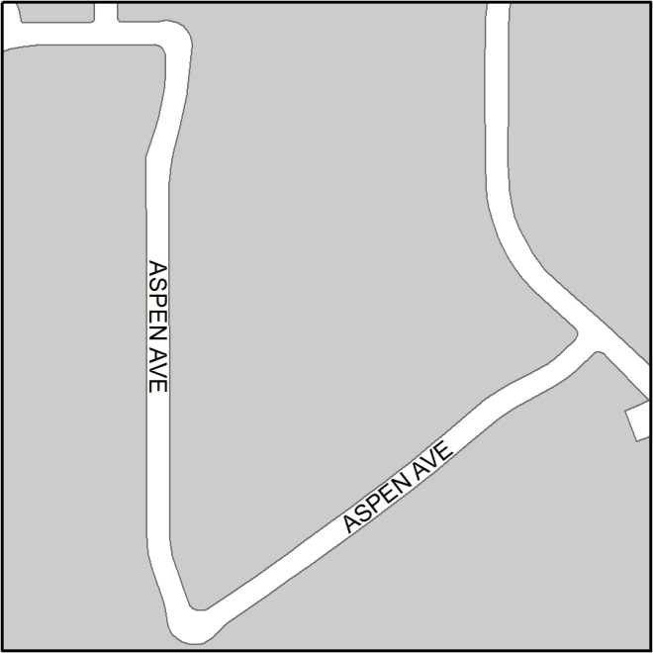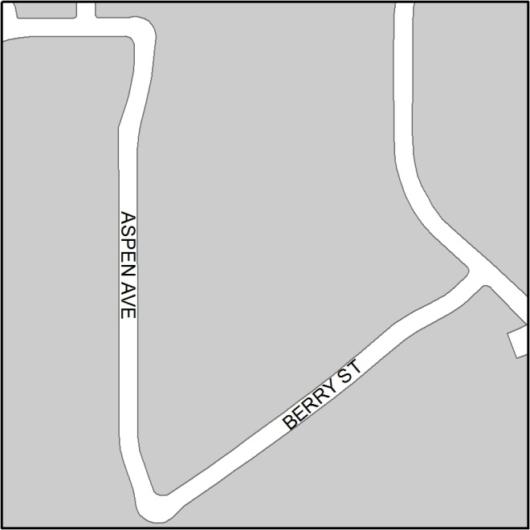b.
CORRECT
INCORRECT

b. When streets can reasonably be considered as either north-south or east-west oriented, they must not cross a street with the same orientation whenever possible (Ex. No East-West meets East-West or North-South meets North-South). See Figure 16.23.060-2 (Orientation).

FIGURE 16.23.060-2: ORIENTATION

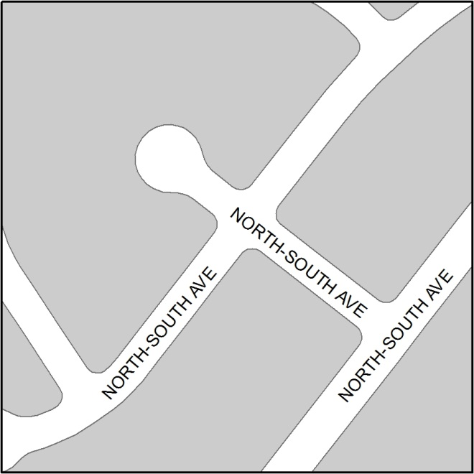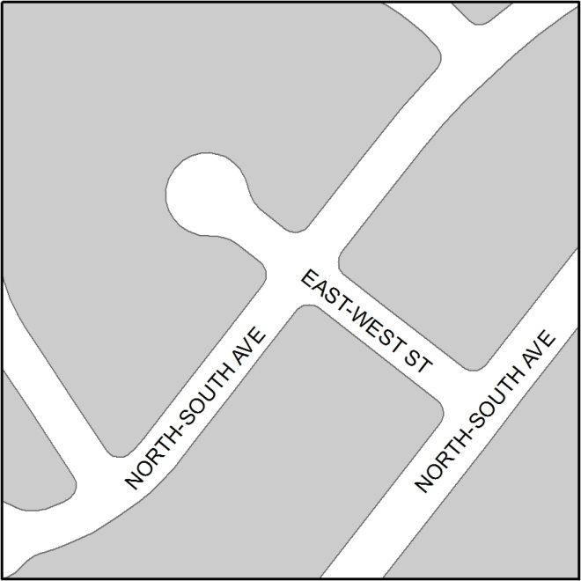
CORRECT
INCORRECT

c. Where there is more than one access point from different streets to a circular loop street, each directional segment of a circular or loop road should be named separately. See Figure 16.23.060-3 (Loop Street).

FIGURE 16.23.060-3: LOOP STREET

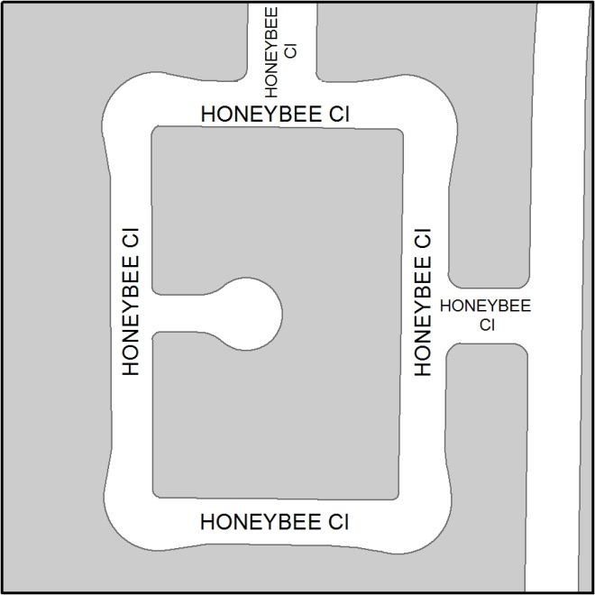
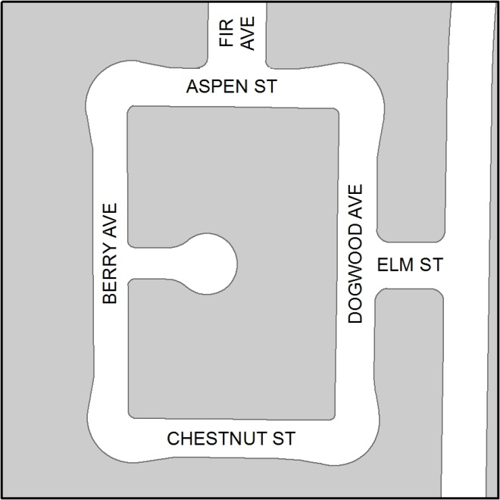
INCORRECT
CORRECT

d. No street name may connect into any other street so as to create more than one intersection of the same named street. See Figure 16.23.060-4 (Intersection).

FIGURE 16.23.060-4: INTERSECTION

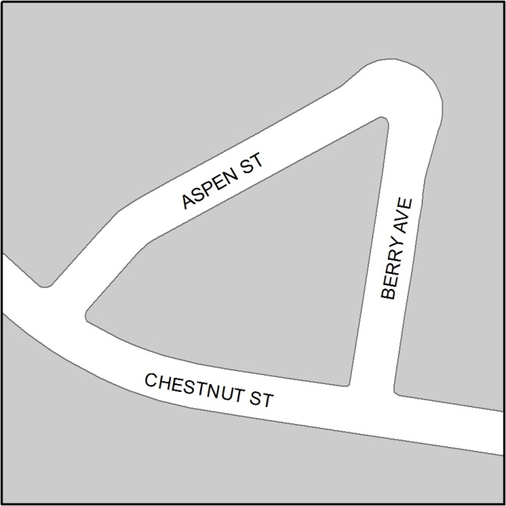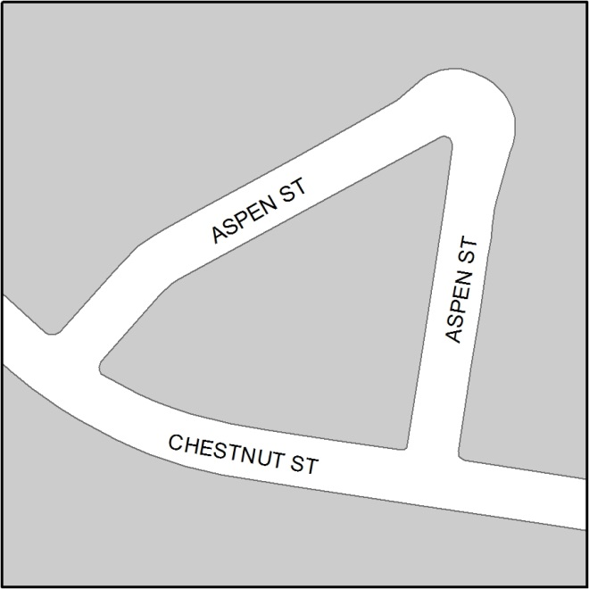
CORRECT
INCORRECT

e. Where the continuation of a through street is restricted by design, separate names shall be designated for the various lengths of the street. See Figure 16.23.060-5 (Through Street).

FIGURE 16.23.060-5: THROUGH STREET

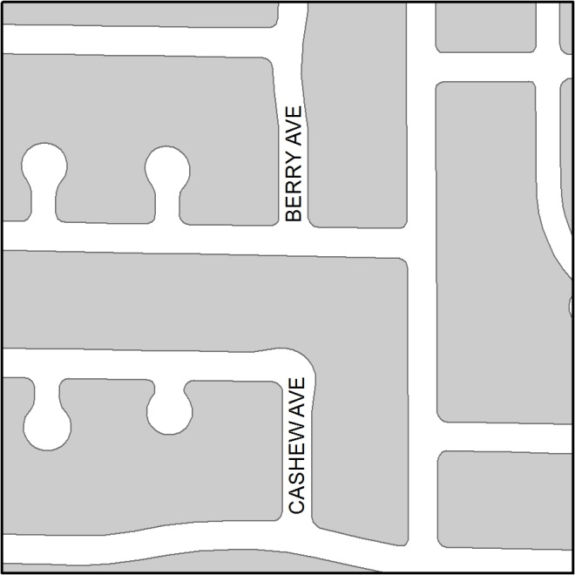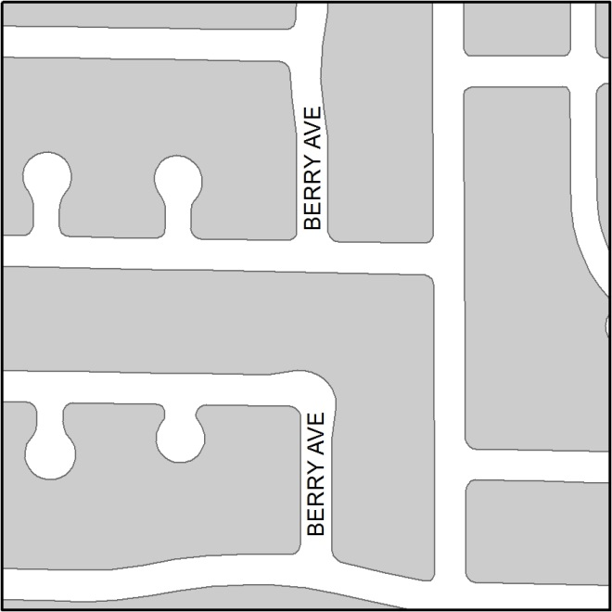
CORRECT
INCORRECT

f. Cul-de-sacs shall be considered a separate street from their cross street as defined in the Addressing Protocols and Guidelines document maintained by City GIS Staff.
g. Frontage roads shall bear the same designation as the main traveled street except when the main traveled street is a designated state or federal route. Frontage roads on state or federal routes shall be assigned names separate from highway designations.

h. A street that crosses city/county jurisdictional boundaries shall be given separate names within each jurisdiction if necessary to avoid any potential addressing conflicts arising from separately maintained addressing grids or systems.
CORRECT

7. Street Annexations

a. When an existing street is annexed into the City, the City reserves the right to rename streets if they are not in compliance with City standards. This includes assigning or changing prefixes to comply with prefix standards (Ex. S AIRPORT WY to N AIRPORT WY).

8. Private Road Names

a. All procedures, standards, and requirements for public road names shall apply to private roads.

b. The private road must serve as the primary access for the properties.

c. The various owners shall be in agreement as to the name of the road before submitting the name for review. If the various owners cannot agree upon a road name, the City shall assign the road name.

9. Street Renaming

a. All street renaming requests must follow the standards outlined in the Addressing Protocols and Guidelines document maintained by City GIS Staff.

K. Addresses

1. Declaration of Purpose

The purpose of this section is to provide a standardized addressing method for properties within the City that minimizes confusion and conflict for the public, delivery agencies, and public safety staff. The process for proposing and approving new addresses is outlined in the Addressing Protocols and Guidelines document maintained by City GIS Staff.

2. Address Rules

a. All new addresses/address changes must be approved by City staff. Address change requests shall be submitted to and reviewed by City GIS Staff. The address change request shall be submitted through the Address Change Request Form.

b. North-south block ranges begin at 100 on either side of YOSEMITE AVE, and east-west block ranges begin at 100 on either side of MAIN ST. New block ranges must fit logically with the existing block grid, and addresses must fit logically within the block ranges.

c. On streets designated north-south, odd numbers must be on the west side of the street and even numbers must be on the east side of the street. On streets designated east-west, odd numbers must be on the north side of the street, and even numbers must be on the south side of the street.

d. Numbers must be sequential along a continuous street.

e. A/B and ½ designations shall be prohibited, except in the following scenarios:

i. If two or more new addresses are required, and they are bounded by sequential numbers above and below (Ex. Between 222 and 226), letter designations are allowed (Ex. 224A and 224B).

ii. If one or more new addresses are required on a parcel with an existing address that cannot be changed, and it is bounded by sequential addresses above and below (Ex. Existing address is 120, between 118 and 122), fractional designations are allowed (Ex. 120 and 120 ½). If the existing address can be changed, A/B designations are preferred.

iii. Each duplex or triplex shall be assigned a numeric address in accordance with City addressing guidelines. Each individual unit of a duplex or triplex shall be given A/B/C designations, as necessary (Ex. 100 MAIN ST, UNIT A and 100 MAIN ST, UNIT B). Any complex larger than a triplex is defined as an apartment complex and should follow the apartment recommendations in the Addressing Protocols and Guidelines document maintained by City Staff.

f. Commercial suites shall be numbered 101, 102, 103, etc. For multi-story buildings, suites shall correspond with the floor number (2nd Floor: 201, 202, 203, etc.). Suites shall ascend in the direction of the street addresses wherever possible.

g. Apartments:

i. If all buildings are located on one parcel on the same side of the street with the same address, the apartment numbers must ascend in a logical order with each apartment receiving a unique number, regardless of building letter or number.

ii. If buildings are located on different parcels and on different sides of the street, with different addresses, apartment numbers may be assigned independently for each address, but it is recommended that each apartment receive a unique number regardless of address and building letter/number.

h. Reserved numbers shall be designated for possible future commercial splits, combines, and/or split and combines. These numbers shall be issued every 20 feet.

i. Newly assigned address numbers must be placed on all structures within 45 days of address assignment. The old address number may be displayed concurrently with the new address number for up to six months after the new address number is assigned. Noncompliance will result in action as outlined in the Addressing Protocols and Guidelines document maintained by City GIS Staff.

j. Annexed properties will be addressed to meet the standards outlined in the Addressing Protocols and Guidelines document maintained by City GIS Staff.

k. City GIS Staff has authorization to correct any errors in a numeric address or street range that violate the standards and shall provide written notice to the owner as outlined in the Addressing Protocols and Guidelines document maintained by City GIS Staff.

l. Further addressing considerations must comply with the Addressing Protocols and Guidelines document maintained by City GIS Staff and are at the discretion of City GIS Staff.

